introduction - open source CI software tool written in JAVA language. this will enable developers to find and solve the defects in code base rapidly and to automate testing of their builds.

1) Jenkins is CI and build server

2)it is used manually, periodically or automatically to build software projects

CI —- developer commit a code to shared repository on regular basis

or when ever the developer commit the code in repos , we need to compile the code and need to generate required artefacts.

cd - when the artefacts are generated in the build pipe line we need to build infrastructure. on the top of infrastructure deploy the code

installtion -1)download java se11 with jdk

2)After installing java, add it to the environmental variables.
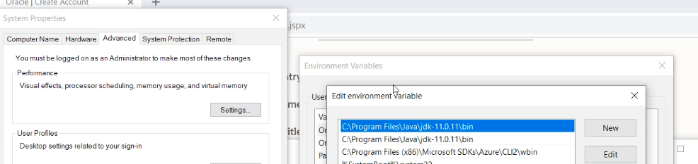

3)edit the system variable and add the above path (exclude bin)

4)now click on jenkins use and install

5)enter local host 8080 in browser .enter the secret from given path

6)need to download plugins to perform any action.

Master - where the jenkins is installed(hosted agent)
Slave - vm’s agent that supports the jenkins. in this jenkins agent is installed.

